In general:

Motion tracker generates data from x, y, z. Yaw, pitch, roll is our priority. Therefore, we set the inputs to these parameters.

Probably Opentrack and Arduino have the order x, y, z, yaw, pitch, roll. (We have yaw, pitch, roll, x, y, z). Therefore we had to set in Opentrack / Options / Output:

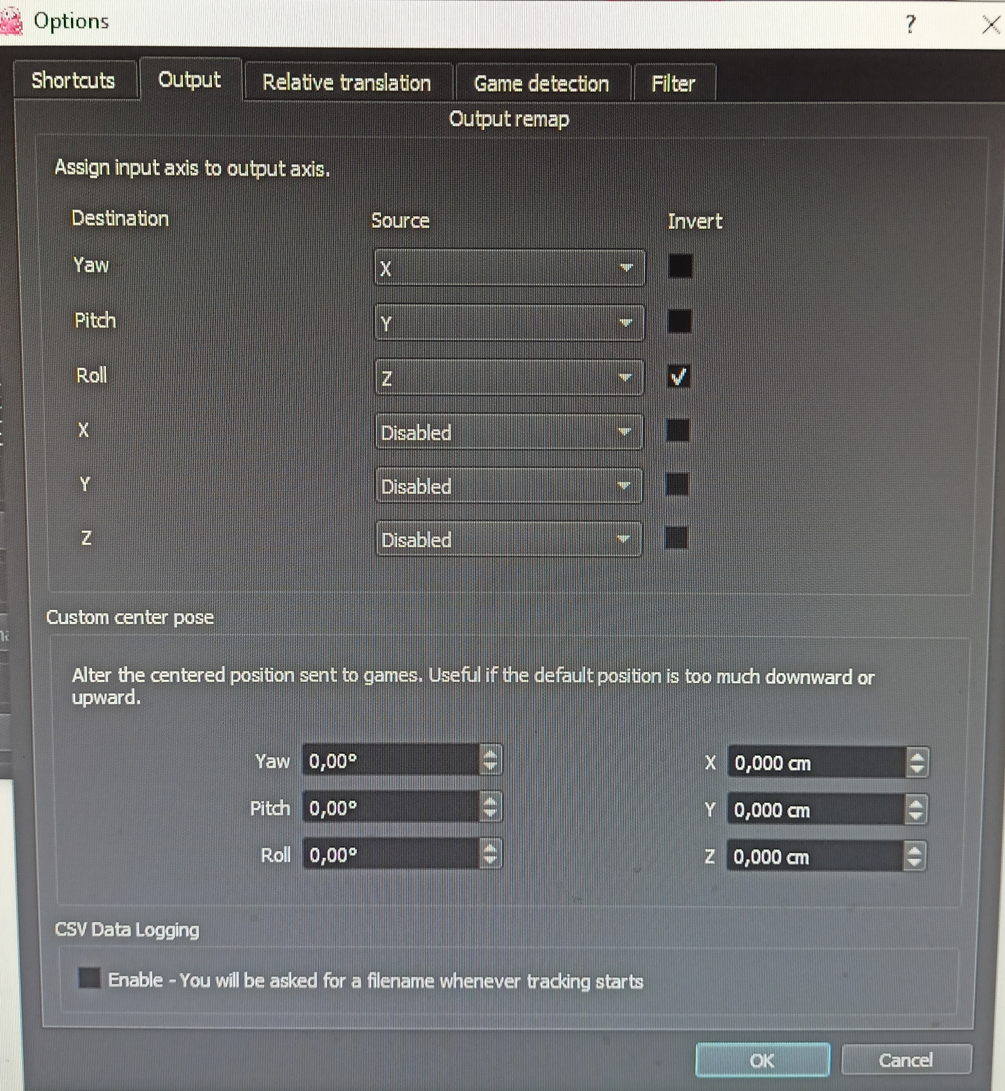

X, y, z, could be set to yaw, pitch and roll - but it doesn't matter since we don't have any data from there.

2. Compared to the default settings, I also changed in Opentrack / Mapping properties / Pitch:

Max input 90 ° and Max Output 180 °

